SellMyCraft Training Manual



Table of Contents

1. Android, what it is and how to use it 3

2. Using an Android device 4

2.1 Using an Android Phone 4

2.2 Using an Android Tablet 6

2.3 The App Launcher 6

2.4 Android voice recognition 7

2.5 Opening and closing ‘Windows’ on Android 7

3. Using SellMyCraft 8

1.1 Overview 8

1.2 Getting started - Installation 8

1.3 Starting up 8

1.4 Navigation and interfacing 9

1.5 Help 11

4. Screen specific help 11

2.1 Login 11

2.2 Main Menu 11

2.2.1 Add Product 12

2.2.2 Edit Info 12

2.2.3 View Products 13

2.2.4 View Sales 13

2.2.5 Synchronization 13

2.2.6 Log-out 13

# Android, what it is and how to use it

Android is an operating system, like Windows for computers or iOS for iPhones and iPads

Google makes Android, and a lot of manufacturers such as Samsung, HTC and Motorola put it on their phones, tablets and now even cameras.  
As well as regular version numbers, every time Google makes a significant update to Android, it names the update after a dessert. The desserts run alphabetically, so you can keep track of different Android versions. In the past few years, devices have upgraded from Eclair, to Froyo, to Gingerbread, to Honeycomb, to Ice Cream Sandwich. The latest devices to be released are currently running Jelly Bean.

Android has a huge app market called Google Play, where you can download books, music and movies as well as apps, all from one place. Amazon also has its own app store for Android phones, giving you even more choice.

You can install new apps on your Android device in two ways. First, you can use the Google Play app that you'll find on your device when you power it up the first time. No need to be connected to a computer; Android devices can install apps all by themselves. Second, you can use the Google Play website on your computer. If you log in with the Google Account you used on your Android device, Google Play will give you the option to install straight to your device. This can be handy when you want a big screen to browse through lots of apps.

There are a couple of super-simple ways to move your personal files on and off an Android device. First, you can use a Dropbox account plus the Dropbox app. Upload everything to Dropbox via your computer, log into Dropbox on your phone or tablet, and they'll all be there waiting for you. Even easier, connect your phone to your computer and treat it like a fancy USB stick — just drag and drop the files, and Android will know how to organize them.

There's software which allows music and movies to be played on Android devices.  
Google makes the Android software and then lets hardware manufacturers such as HTC and Samsung install it on their phones and tablets. Device manufacturers usually add their own design tweaks to the standard Android operating system. These design tweaks are known as skins, and manufacturers use them to help Android devices stand out from the competition. The app drawer is where you can find all of the apps installed on your device. On Apple devices, all of your apps are live on your home screens. But Android devices have (up to) seven home screens that you can fill with your favorite apps and widgets for quick access — any apps you don't choose to keep on your home screen will still be in your app drawer.

Widgets are one of our favorite features of Android. Super useful at both displaying information and saving power, they are a little like snapshots of apps that live on your home screens. Widgets come in all different sizes. They can display simple things like how much data you've used this month or show more complex things like your Facebook news feed. Because they're designed for basic interactions like posting updates to Facebook or Twitter, widgets can help you save battery power because you don't need to open up the full app every time you want to make a simple update or reply to comments.

You need a Google account to use Android. You don't have to use any of the specific Google services like Gmail on a daily basis if you don't want to, and Google lets you add other email accounts to your Android phone or tablet. But if you really don't want a Google account, Android might not be right for you. Google's software and cloud services are really slickly integrated into the Android experience, and you'll miss out on some of the best features of Android if you don't want to use them. You can enter contacts into Gmail, and they'll be automatically synced to your phone, or you can transfer saved numbers off your SIM card.

# Using an Android device

## Using an Android Phone

The Android desktop is composed of multiple home-screen panels. Depending on the version of Android that your phone uses and on whether your device has a specialized overlay, you may have five to seven home-screen panels.

When you power up your phone for the first time, you'll see the main home-screen panel. This panel is typically centered, and you can access additional panels on either side of the main one by swiping your finger left or right. What goes on the home-screens is up to you. You can fill the space with any combination of shortcuts, widgets, and folders.

As you'd expect, short-cuts are small icons that let you load apps or other functions on your phone; they function much like the ones you see on a PC desktop. You can set a shortcut to do anything from opening a program to linking to a specific Web page to initiating a phone call.

To add a shortcut, simply press and hold your finger on any open space on your home screen, and select Shortcuts from the resulting pop-up menu. From there, select Applications (to add an app), or Direct dial or Direct message (to create a shortcut for calling or texting a friend), or Bookmark (to open a Web page), or Directions (to activate turn-by-turn navigation to a specific destination).

Widgets are dynamic programs that operate directly on your home-screen. They can perform any number of functions-giving you the latest weather, for example, or letting you play music from either your personal collection or from the Internet. Should you want more, you can download additional widgets from the Android Market.

To add a widget, press and hold your finger on an open space, as you would to create a shortcut (above). This time, though, select the Widgets option from the pop-up menu. Even if you haven't downloaded anything from the Android Market, you should have a handful of options built into your phone. Start by adding the Power Control widget; it creates a handy dandy one-touch toggle control for you phone's Wi-Fi, Bluetooth, GPS, data syncing, and screen brightness.

Folders are a good way to keep your content organized while simultaneously expanding your home-screen space. A folder lets you group multiple shortcuts in a single space. When you tap on a folder, a box pops up showing all of the shortcut icons inside that folder. You can fill one folder with one-touch dialing shortcuts to all of your favorite contacts, and another, perhaps, with various phone-number lookup utilities. Folders help you add many useful things to your home-screens without eating up a lot of space.

To add one, press and hold your finger on an open space. Select *Folders*, and then *New Folders*. Then drag and drop as many shortcuts into the folder as you wish. To give it a custom name, tap the folder once to open it, and then hold your finger along the top bar until the Rename folder dialog box appears on your screen. To move any shortcut, widget, or folder, simply touch and hold your finger to it. After a couple of seconds, it will seem to lift up from the screen. You can then drag it anywhere, including to another panel and drop it wherever you like. As you drag and drop, you'll also see a trash symbol at the bottom-center of the screen; slide any icon down onto the trash symbol to remove it from the home screen altogether.

Android phones have four standard keys: a Back button, a Menu button, a Home button, and a Search button. These keys will help you navigate through your phone more easily, no matter what program or process you're running.

Pressing the Back key takes you back one step to whatever you were doing prior to the beginning of your current step. It works in Web navigation, e-mail navigation, or navigation to a previously open program.

Pressing the Menu key brings up a list of options relevant to the area of the phone you're currently using. When you press it on the home-screen, it permits you to access your phone's settings and other customization options.

The Home key has two functions: If you press it once, it takes you back to your home screen. If you press and hold it, it allows you to multitask and switch to other programs you've recently used.

Pressing the Search key produces different results depending on where you are in Android at the time. From your home screen, it brings up a Quick Search Box that you can use to search the Web and your phone at the same time (Android will return the most relevant results from either domain as you type). From within an app, the Search key typically starts a search specific to that program-enabling you to search exclusively within your e-mail, for example, or within your contacts list.

## Using an Android Tablet

Your tablet is essentially a small 10-inch laptop with 6 to 12 hours of battery life. Simultaneously, a tablet has no dedicated keyboard or mouse hardware. The intent of a tablet is to make computing very personal, very movement-friendly, and very sharing-friendly. You can take your web and music and photos to the living room couch, to the bus, to the office meeting, to your friends' homes, and even to the bathroom, all with the same portability as a copy of Time Magazine. Tablets are designed more for consumption than for production. This means: tablets are for light gaming, reading web pages and ebooks, listening to music, viewing photos and movies, presenting/sharing pictures with friends, and snapping candid photos and videos. Conversely, because of the small screen and lack of hardware keyboard and mouse, tablets are not great for serious writing, heavy-duty accounting, or very detailed document processing. Touch-entry and typing are the big input differences between a tablet and a personal computer. Instead of a mouse, your tablet uses touch-taps and drags with a single finger at a time and 'pinch/reverse-pinch' gestures with two fingers at a time. Typing on a tablet is done in one of three ways: one-handed (while the other hand holds the tablet), two-thumbed while holding the tablet in both hands, or full typing while the tablet sits on a table.

Android 4.x uses more commands than its competitor, Apple iOS, and there are more widgets and menus in Android. You will need to learn more steps to make full use of your Android device, but you will also get more granular control that you would with an Apple iPad.

There are four basic touch commands on an Android tablet:   
1) press, aka 'tap' (a finger version of a mouse click)

(tap/touch, tap an icon to open it for example)  
2) press-hold (press, use on an app to get more options for example)  
3) drag (press and move, can move icons on your screen around for example)  
4) pinch (allows for zoom functionality)

Most Android touch commands are single finger. Pinch requires two fingers simultaneously.

## ****The App Launcher****

You can always find all of your apps in the app launcher. To open the launcher, simply tap the square icon at the bottom of the screen. The launcher looks different depending on what version of Android you have, and whether or not your phone has a custom overlay.

Within the app launcher, you can tap any app's icon to run the program, or press and hold it to drag it directly onto the home screen as a shortcut.

## Android voice recognition

Android also supports voice recognition. The system is however far from perfect. Wherever there is text entry available on the tablet screen, you will see a microphone button on the soft keyboard. Press that microphone button, press 'speak now', and then speak clearly into the tablet. Depending on your accent and articulation, the tablet will translate your voice with 75 to 95% accuracy. You can choose to backspace or type over any of the voice recognition text. If you wish to try voice recognition, then experiment with the Google search in the top left of your tablet home page.

## Opening and closing ‘Windows’ on Android

You do not 'close' windows in Android the same way you would in Microsoft. Instead: you let Android partially close (hibernate) and fully close your windows for you.   
How Android Manages the Partial and Full Closing of Software Windows:   
If you no longer wish to use an Android program, you simply leave the program by doing any of the four options:   
1) tap the 'back' arrow button  
2) navigate to 'home'  
3) launch a new program,   
4) or use 'recent apps' button to launch a previous program.   
  
As soon as you leave a program, and that program is not doing anything, then the program 'hibernates'. Hibernation is a partial close, where it is moved from system memory into storage memory. This hibernation frees up system memory, yet still remembers the state and configuration of the hibernating software.   
  
The benefit of this hibernating-type closing is that 80% of the time, you can return to the exact same screens when you re-launch the program. Not all Android programs strictly follow this, but this feature is very useful nonetheless.   
  
So, in short: you don't personally close windows in Android. You let Android close windows behind you as you navigate.

# Using SellMyCraft

## Overview

The SellMyCraft e-Commerece application helps you reach and sell your products to a wider audience.

This application is designed using basic4android for android mobile devices. And is designed to be usable for touch-screen and point and click type interfacing.

## Getting started - Installation

To install the application, you must firstly either download the SellMyCraft.apk ([www.androiddownloads.com/sellmycraft.apk](http://www.androiddownloads.com/sellmycraft.apk)) file from the android store or website to your mobile device.

Then simply run the file and follow the prompts provided, once completed the program will be installed and usable on your mobile device.

## Starting up

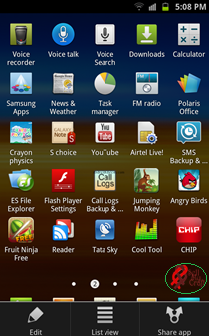Once the application is installed and loaded, you can find and start the application by clicking and/or opening the applications logo and executable file which will be located on your device where all other applications are found.

## Navigation and interfacing

Upon starting the app you will be able to select the language with which the application would run on via a drop-down box which you click on and then select the appropriate language of your choice.

The program is navigated through a series of screens that is accessible once log in is successful. Clickable and usable buttons are represented and identifiable by icons and colour.

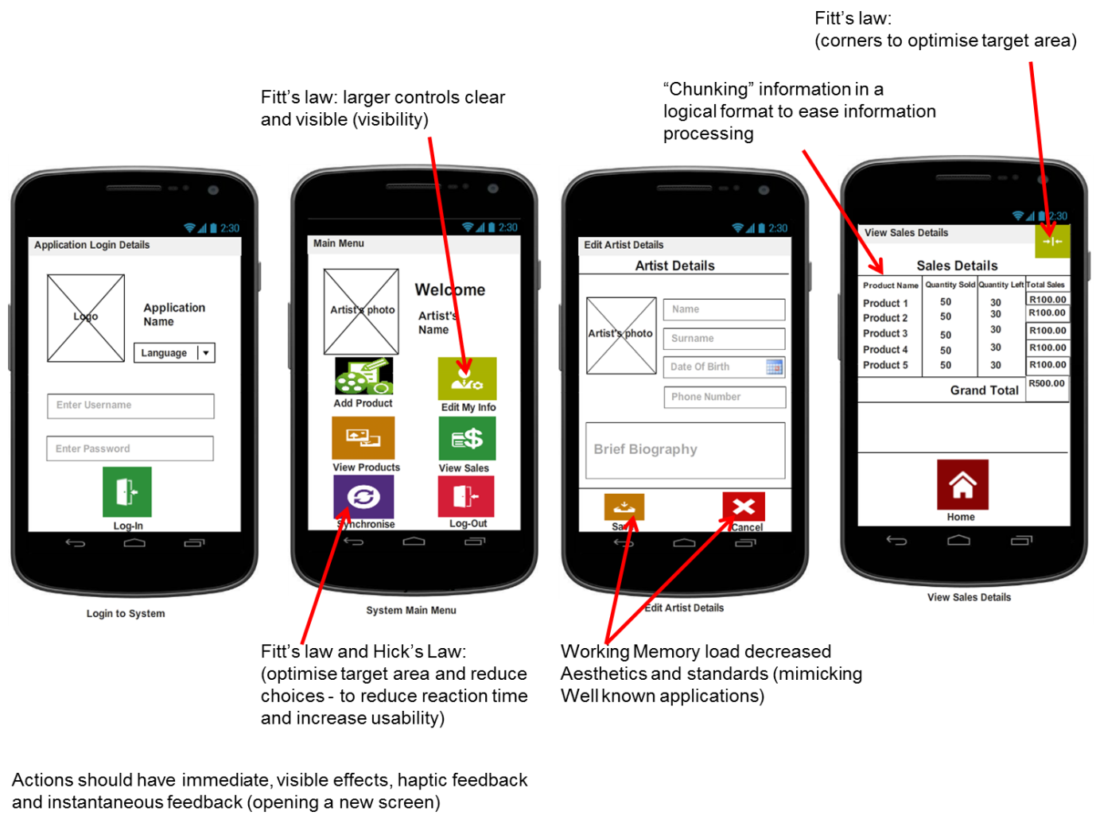User input comes in the form of clicking or selecting editable text boxes and entering the appropriate information where applicable and when prompted. Example, log in information at application start-up.

External interfacing is conducted with regards to the application making use of the phone’s camera and default camera application.

The interface and navigation structure of the application is depicted below:

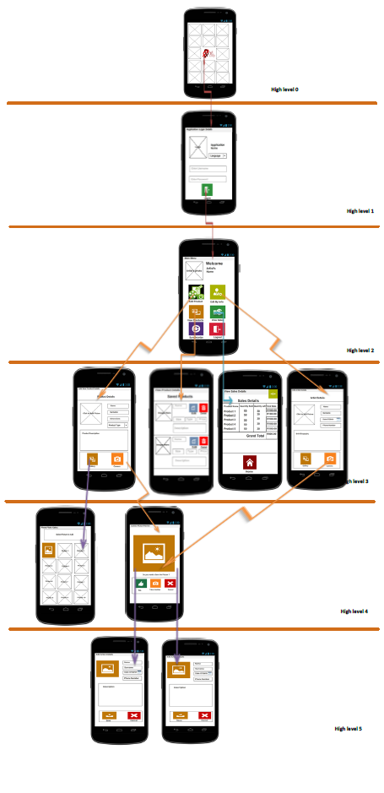

## Help

Help is provided within the app so you do not need to consult this manual, there is help provided for each screen and interface encountered within the application.

To access the application’s built in help, simply click on the Help icon present within a screen identifiable by its icon’s representation:

# Screen specific help

## Login

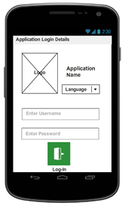

Upon application start-up the *Login* screen appears. Where-by the application’s *Language* setting is changeable via clicking on the presentable languages and selecting the language desired.

A username and password must be entered into the appropriately marked fields and if correct will permit the user access into the application.

## C:\Users\g10g0351\Dropbox\Project Management Documents\ICONS and Mockup Screens\Mockup Screens\Main Menu.PNGMain Menu

Upon login, the *Home* screen will be displayed with the photo and name of the user. The user can do 6 things on the *Home* screen namely:

* Add Product
* Edit My Info
* View Products
* Views Sales
* Synchronize
* Logout

### 2.2.1 Add Product

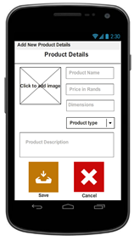

Select the *Add Product* button on the Home screen. A new window will be displayed with fields where the new product details can be entered such as product name and price. A picture of the product will have to be uploaded by selecting an existing picture from phone’s gallery or by way of taking a new picture using the phone’s camera. When satisfied with the details and the uploaded picture, select the *Save* button and these changes will be saved on the mobile application. Alternatively, select the *Cancel* button and the changes will not be saved and the *Home* screen will be displayed. The *Back* button can also be used to go back to the *Home* screen.

### 2.2.2 Edit Info

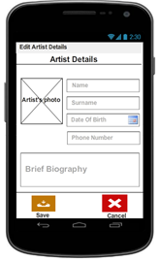

Select the *Edit My Info* button on the Home screen. A new window will be displayed with fields with the artist details and picture displayed. These displayed details and picture can be edited as required. The artist picture can be changed by clicking on the current picture and either uploading an existing picture from phone’s gallery or by way of taking a new picture using the phone’s camera. When satisfied with the artist details and the uploaded picture, select the *Save* button and these changes will be saved on the mobile application. Alternatively, select the C*ancel* button and the changes will not be saved and the *Home* screen will be displayed. The *Back* button can also be used to go back to the *Home* screen.

### 2.2.3 View Products

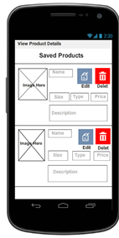

Select the *View Products* button on the Home screen. A new window will be displayed showing all products that are currently on sale including all the relevant details such as price. These details can be changed by selecting the product with the details that need to be changed and making the relevant changes in the fields presented. When satisfied with the edited details, select the *Save* button and these changes will be saved on the mobile application. Alternatively, select the *Cancel* button and the changes will not be saved and *View Products* window will be redisplayed. The *Back* button can be used to go back to the *Home* screen.

### 2.2.4 View Sales

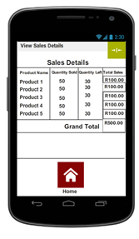

Select the *View Sales* button on the Home screen. A new window will be displayed showing the details of all sales that have been made in tabular format. Details about the product sold, quantity sold, quantity left and total cost will be shown. The Sales details are not editable. Select the *Back* button to go back to the *Home* screen.

### 2.2.5 Synchronization

Select the *Synchronise* button on the Home screen. This allows all changes or updates to be saved on the Teleweaver database. It is important to ensure that this is done at all times when any changes are made.

### 2.2.6 Log-out

Select the *Logout* button on the Home screen. This will close the mobile application and login details will have to be provided to access the application.